Personal Finance Advisor Bot: Project Documentation
Course: BFSI (Skill Wallet / SmartInternz) Author: Rajvardhan Nanabhau Deore, Roll No. 32119 Repository: https://github.com/rajvardhandeore04-cpu/Personal-Finance-Advisor-Bot Technology stack: React 19, TypeScript, Tailwind CSS v4, Vite, Node.js, Express, Google Gemini (@google/genai)

1. Introduction
Personal Finance Advisor Bot is an AI-assisted web application that helps users track their money, plan budgets and improve their savings. Users log income and expenses, set category budgets and savings goals, and see live figures on a dashboard. When they ask the advisor a question, generate a budget or open a monthly report, the front end sends the relevant figures to an Express server, which builds a prompt, calls Google Gemini and returns structured advice.
The application has two fallbacks. The server uses rule-based advice if the Gemini key is missing or the AI call fails, and the front end uses its own analysis engine if the server cannot be reached. The app therefore keeps working without an AI key.

1.1 Problem statement
Many people do not track where their money goes and find it hard to turn raw numbers into a plan. A conversational advisor that reads the user's own figures can point out overspending, suggest savings steps and produce a monthly summary.

1.2 Objectives
- Let users record income and expenses and see savings rate, budget usage and emergency runway.
- Provide personalized financial guidance based on the user's actual income, expenses, budgets and savings goals.
- Generate a realistic monthly budget using a standard framework such as 50/30/20.
- Produce a printable monthly report with a clear health status.
- Keep the AI key on the server and keep the app working when the AI is unavailable.

1.3 Disclaimer
The advice is educational. It is not a substitute for a licensed financial advisor and does not guarantee any financial outcome.

2. Scenarios

Scenario 1: Asking the advisor for help
A user opens the advisor and asks how to save more this month. The front end sends the question, the last messages of the conversation and the user's financial context to the server. The server returns a Markdown reply and a structured advice object containing a summary, overspending alerts, savings opportunities and action items.
Activities
- 1.1 The user opens the advisor chat and types a question.
- 1.2 The front end sends the message, recent history and financial context to POST /api/advisor/chat.
- 1.3 The server checks that a message is present.
- 1.4 The server calls Gemini, or uses the rule-based engine if no key is set.
- 1.5 The server extracts the structured JSON block from the reply and returns the cleaned text with the structured advice.
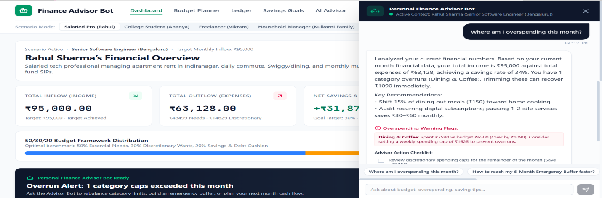
- 1.6 The user reads the advice and decides which actions to take.

Scenario 2: Generating a monthly budget
A user enters a monthly income and chooses a framework. The server returns category-wise limits, a savings target and a short rationale.
Activities
- 2.1 The user opens the budget generator and enters income and framework (default 50/30/20).
- 2.2 The front end calls POST /api/advisor/generate-budget.
- 2.3 With a Gemini key, the server asks the model for a JSON budget. Without a key, it allocates fixed percentages of income per category.
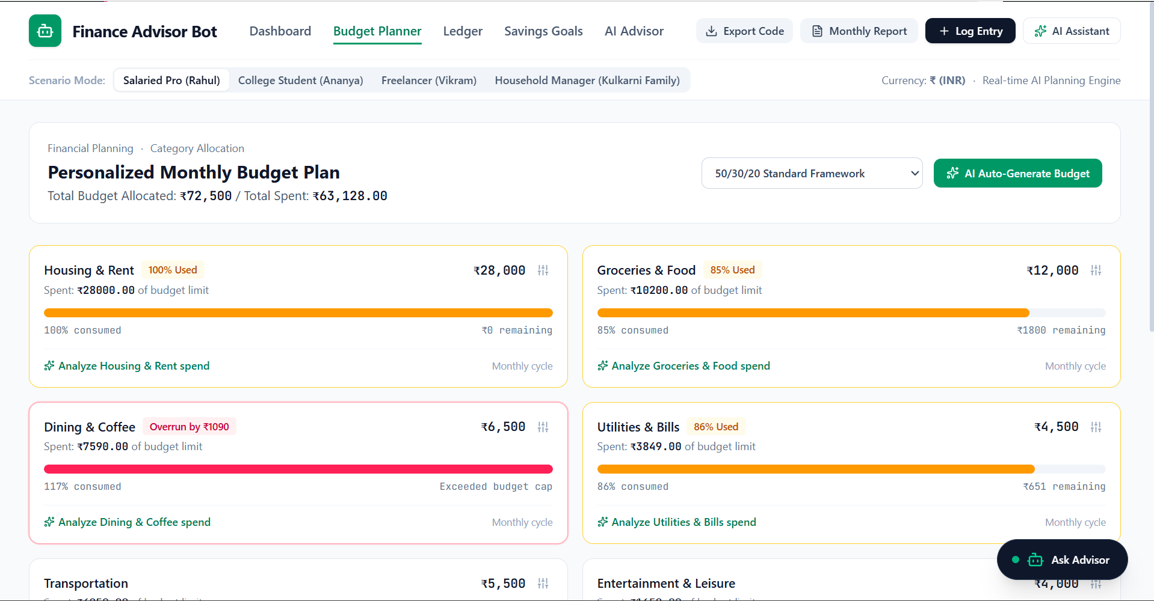
- 2.4 The front end displays the limits, the savings target and the rationale.

Scenario 3: Reviewing the monthly report
At the end of the month the user requests a report. The server summarizes income, expenses and net savings, assigns a health status and lists overruns and recommendations.
Activities
- 3.1 The user opens the monthly report page.
- 3.2 The front end calls POST /api/advisor/monthly-report with totals and the category breakdown.
- 3.3 The server computes net savings and savings rate and builds the report with Gemini or the rule-based engine.
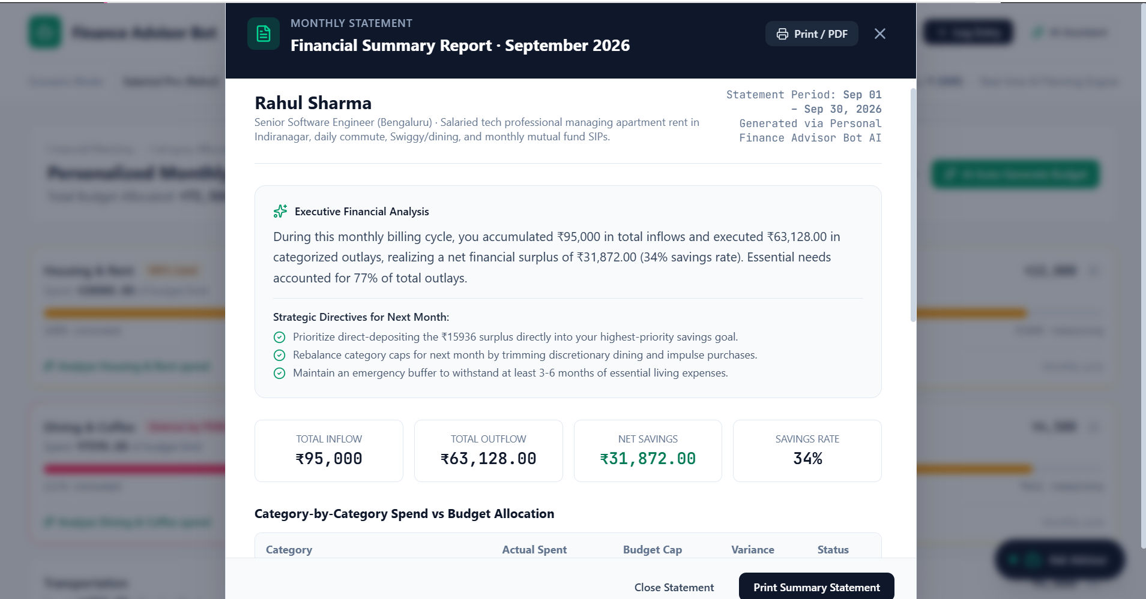
- 3.4 The report shows the executive summary, health status, top overruns, recommendations and next month's savings target.

Scenario 4: Logging transactions and tracking savings goals
A user picks a demo persona (salaried, student, freelancer, household or custom), logs a new expense and deposits money toward a goal. The dashboard recalculates immediately in the browser.
Activities
- 4.1 The user selects a scenario in the header, and the profile, transactions, budgets and goals load.
- 4.2 The user opens Add Transaction and enters type, amount, date, description, category, payment method and the essential toggle.
- 4.3 The app recalculates inflow, outflow, net savings, savings rate, category usage and emergency runway.
- 4.4 In Savings Goals, the user deposits an amount or adds a new goal and sees the progress update.
- 4.5 In the Ledger, the user filters transactions and exports them as CSV.

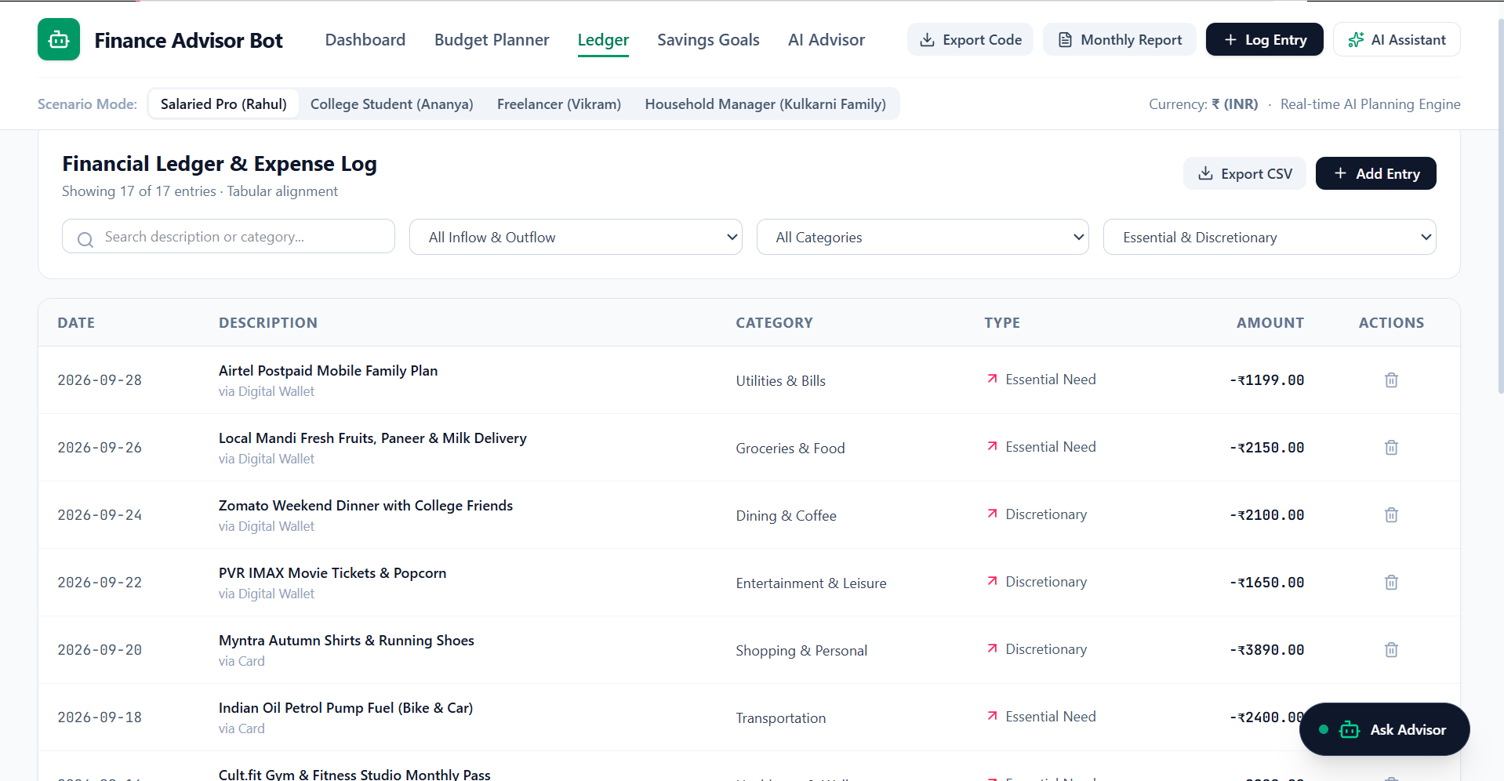
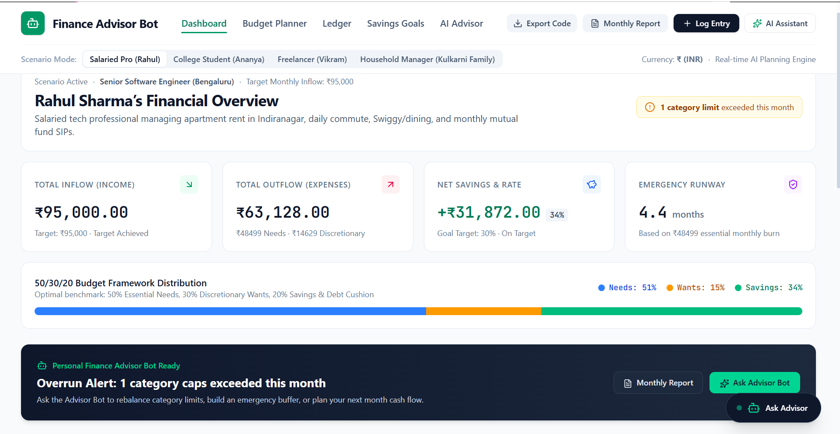

Scenario 5: Projecting the month and stress-testing
A user opens Predictive Analytics to see where the month is heading and how a shock would affect them.
Activities
- 5.1 The app projects month-end spending from the daily run-rate.
- 5.2 The user sets an income drop (percent) and a simulated emergency expense.
- 5.3 The simulator shows the resulting net position after the shock.

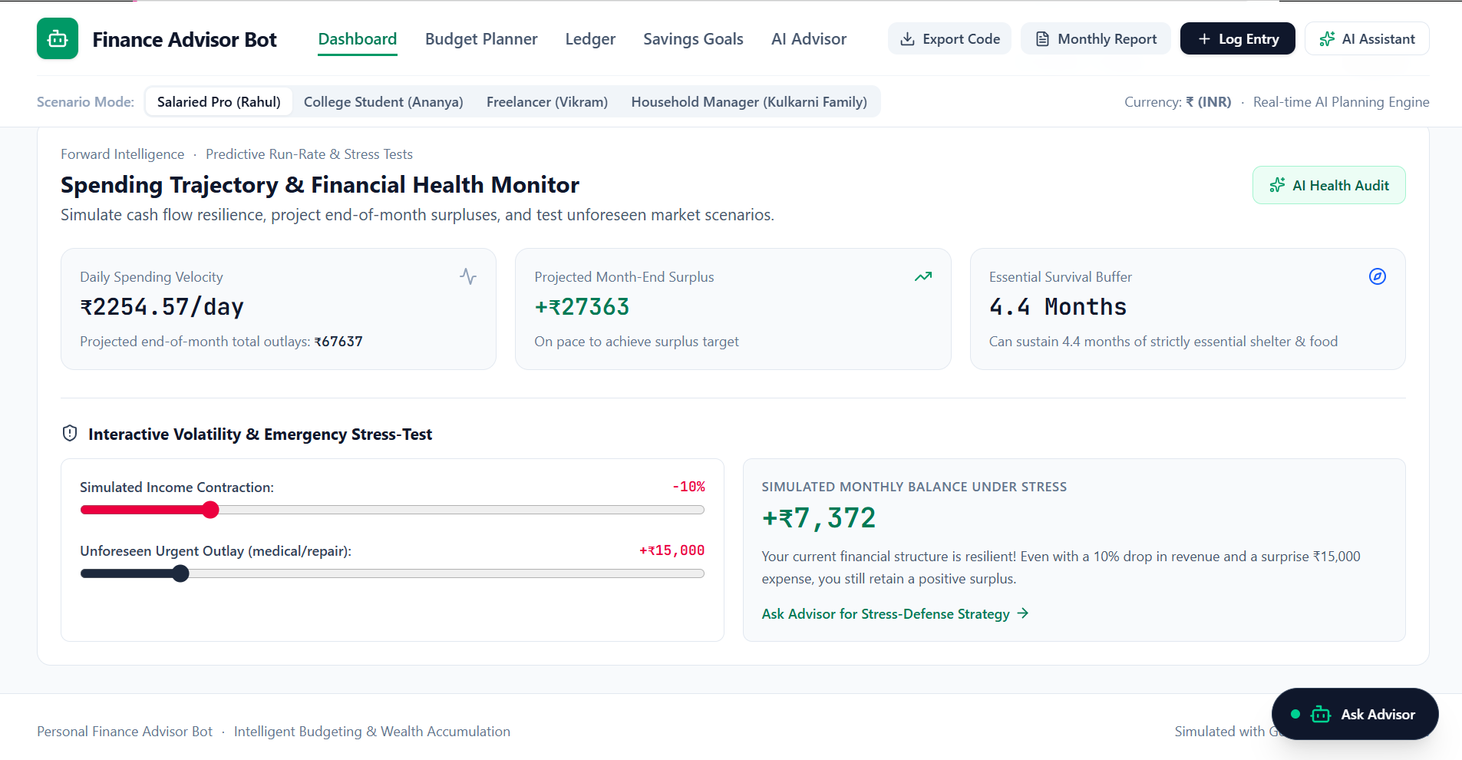
3. Technical Architecture

3.1 Overview
The application is a single Node.js project. One Express server provides the API and also serves the front end. In development the server mounts Vite as middleware; in production it serves the built dist/ folder. All dashboard figures are calculated in the browser from the current transactions, budgets and goals. The server only builds prompts and returns advice.
[ Browser: React + Vite UI ]
| JSON over HTTP (/api/advisor/*)
v
[ Express server (server.ts) ]
|-- request checks
|-- rule-based advice engine (fallback)
|-- Gemini client (@google/genai) --> [ Google Gemini API ]
'-- Vite middleware (dev) / static dist (production)

3.2 Components
Component | Responsibility
App.tsx | Holds profile, transactions, budgets and goals in state; calculates metrics; routes the tabs
Header | Navigation (Dashboard, Budget Planner, Ledger, Savings Goals, AI Advisor) and scenario switcher
OverviewCards | Inflow, outflow, net savings, emergency runway and 50/30/20 distribution
BudgetPlanner | Category limits, progress bars and the AI budget generator
TransactionLedger, AddTransactionModal | Log, search, filter and export transactions
SavingsGoals | Goal progress, deposits and new goals
AdvisorChatDrawer | Chat with the AI advisor and structured advice cards
MonthlyReportModal | Printable monthly report with an AI summary
PredictiveAnalytics | Run-rate projection and stress-test simulator
financialAdvisorEngine.ts | Front-end rule-based advice when the server is unreachable
server.ts | Express API, Gemini calls, server-side fallback, static file serving
.env | Gemini API key and port

3.3 Security and configuration
The Gemini API key is read from the GEMINI_API_KEY environment variable on the server and is never sent to the browser. .env is excluded from version control and .env.example documents the variable. If the key is missing or still set to the placeholder MY_GEMINI_API_KEY, the server uses the rule-based engine.

3.4 Data handling
The server does not store data. The financial context arrives in each request and is used only to build the response. The chat endpoint sends only the last 6 messages of the conversation to the model. In the browser, all data is held in React state and resets when the page is refreshed.

4. API Design

4.1 POST /api/advisor/chat
- Input: message (required), conversationHistory, financialContext (profile, metrics, budgets, savings goals, overspent categories, recent transactions).
- Output: reply (Markdown) and structuredAdvice (summary, overspendingAlerts, savingsOpportunities, actionItems, projectedSavingsNextMonth).
- Errors: 400 if the message is missing. If the AI call fails, the server returns rule-based advice instead of an error.

4.2 POST /api/advisor/generate-budget
- Input: profile, currentExpenses, monthlyIncome, framework (default 50_30_20).
- Output: framework, monthlyIncome, recommendedBudgets (category, limit, reason), savingsTarget, rationale.
- Errors: 500 if the AI call fails.

4.3 POST /api/advisor/monthly-report
- Input: profile and reportData (totalIncome, totalExpenses, essentialExpenses, discretionaryExpenses, categoryBreakdown).
- Output: executiveSummary, financialHealthStatus, topOverrunNotes, strategicRecommendations, nextMonthTargetSavings.
- Errors: 500 if the AI call fails.

4.4 GET /api/download-project
Returns the project archive personal-finance-advisor-bot.tar.gz if it exists on the server, otherwise 404. AI Studio added this route; the app does not need it.

5. Financial Logic

5.1 Savings and savings rate
Net savings = total income minus total expenses.
Savings rate = net savings divided by total income, multiplied by 100. If income is zero, the rate is treated as 0 so the application never divides by zero.

5.2 Health status
Savings rate | Status
20% or more | Optimal
10% to below 20% | Stable
Below 10% | Attention Needed

5.3 Overspending alerts
For each category where spending is greater than the budget, the server records the overage (spent minus budget) and suggests a weekly cap of about one quarter of the monthly budget.

5.4 Rule-based budget allocation
When no Gemini key is set, the budget generator uses these shares of monthly income:
Category | Share
Housing and Rent | 30%
Groceries and Food | 12%
Dining and Coffee | 5%
Utilities and Bills | 6%
Transportation | 8%
Healthcare and Wellness | 5%
Entertainment and Leisure | 5%
Subscriptions | 2%
Miscellaneous | 4%
The fallback savings target is 23% of income. When Gemini is used, the prompt asks for a savings target of 20%.

5.5 Emergency runway, projection and stress test
- Emergency runway (months) = savings held in emergency or buffer goals divided by essential monthly expenses.
- Month-end projection = (total expenses divided by days elapsed) multiplied by days in the month. The code currently fixes these at 28 and 30.
- Stress test: net = income reduced by the chosen percent, minus current expenses, minus the simulated emergency expense.

6. Project Workflow

Milestone 1: Requirements and setup
- Define the problem, users and features.
- Set up the Node.js, Express, TypeScript and Vite project.
- Obtain a Gemini API key and configure .env.

Milestone 2: Backend and AI integration
- Build the Express server and the three API routes.
- Write the prompts and the structured JSON output format.
- Add the rule-based fallback for missing keys and API errors.

Milestone 3: Front end
- Build the React interface: dashboard, budget planner, ledger, savings goals, advisor drawer, monthly report and predictive analytics.
- Connect the AI features to the three API endpoints.
- Add loading and error states and the front-end fallback engine.

Milestone 4: Testing and documentation
- Test each endpoint with and without a Gemini key.
- Verify the calculations with known numbers.
- Capture screenshots and finish the README and this report.

7. Testing and Validation
This section should list only tests that were actually run. Suggested test cases:
Test | Expected result
Chat request without message | 400 with an error message
Chat request with no API key | Rule-based reply and structured advice
Chat request with a valid key | Gemini reply with parsed structured advice
Gemini returns invalid JSON block | Server falls back to rule-based structured advice
Budget request with income 75,000 and no key | Nine categories, savings target 17,250
Monthly report with income 0 | Savings rate 0, no crash
Savings rate of 25%, 15% and 5% | Optimal, Stable, Attention Needed
Record the actual results of each test in a results table before submission.

8. Limitations and Future Work

Limitations
- No database or user accounts: all data lives in React state and resets on refresh.
- Predictive analytics uses fixed values (28 of 30 days elapsed), so the projection is illustrative.
- The fallbacks use fixed percentages and generic tips, some with fixed dollar amounts.
- The server's fallback budget text describes a 56/17/27 split that does not match its category percentages.
- AI output may be inaccurate and must be reviewed by the user.

Future work
- Add user login and a database (for example SQLite) to store profiles and history.
- Add credit-score and debt tracking (CIBIL, DTI/FOIR and utilization) for the Indian context.
- Add charts for spending trends.
- Add automated tests and deployment.

9. Outcome
The project delivers a working full-stack prototype that combines a conversational AI advisor, a budget generator and a monthly report, with a safe fallback when the AI is unavailable. It gave practical experience with Express APIs, prompt design, structured AI output, environment-based configuration and building resilient AI features.

10. Conclusion
Personal Finance Advisor Bot shows how generative AI can make personal finance guidance easier to understand while the server keeps control of the calculations and the API key. Screenshots, test results and any added features should be filled in from the running application before submission.

